**LIBRARY MANAGEMENT SYSTEM**

**By**

Sreenidhi Rajesh Dulipati

Ritesh Shenoy

## Table of Contents

MAIN MENU FOR LIBRARY MANAGEMENT SYSTEM 3

CLASS DESCRIPTION 3

UML DIAGRAM 5

DDL STATEMENTS 6

TABLE CREATION 6

LIST OF DATABASE ENTITIES 7

ENTITY RELATIONSHIP DIAGRAM 9

WORKING-SCREENSHOTS 10

DATABASE-SCREENSHOTS 16

ERROR HANDLING-SCREENSHOTS 19

# MAIN MENU FOR LIBRARY MANAGEMENT SYSTEM

* *Administrator:*
  + Login
  + Add, update and delete the library books/articles.
  + Add, update and deletion of staff members.
  + Search books/articles in the library.
  + Logout
* *Staff Members:*
  + Login
  + Add, update and delete the library books/ articles.
  + Search books/articles in the library.
  + Logout
* *Student:*
  + Login
  + Search books/articles in the library.
  + Borrow books/articles
  + Check referral Books/ articles
  + Logout

# CLASS DESCRIPTION

* The project is segregated into three packages model, view and controller as per MVC design pattern.
* LibraryManagementMain acts as main class file for the project.
* The Books acts as a superclass which has the sub class as BorrowBooks classes.
* Display class in controller package acts as a superclass for DaoModel class in the model package.
* AdminOperations Interface is implemented which is extended by Administrator class in controller package.
* Display class in controller package acts as a subclass for Administrator class in controller package.
* StaffDisplay class extends Staff class in controller package.
* DisplayOfRecordsForStudentsController class in controller package acts as a subclass for Student class.
* BookOperations acts as interface which is being implemented by Admin and Staff.
* Admin and Staff has the privileges for creation, updating and deletion of books.
* Admin has access to create, update and deletion of Staff members.
* Admin, Staff and Student can list and search available books/ articles.
* Student has access to borrow books/articles.

**Files and Classes**

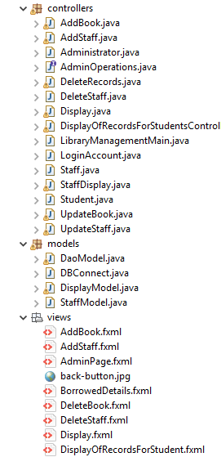

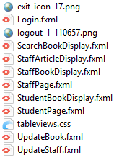

# UML DIAGRAM

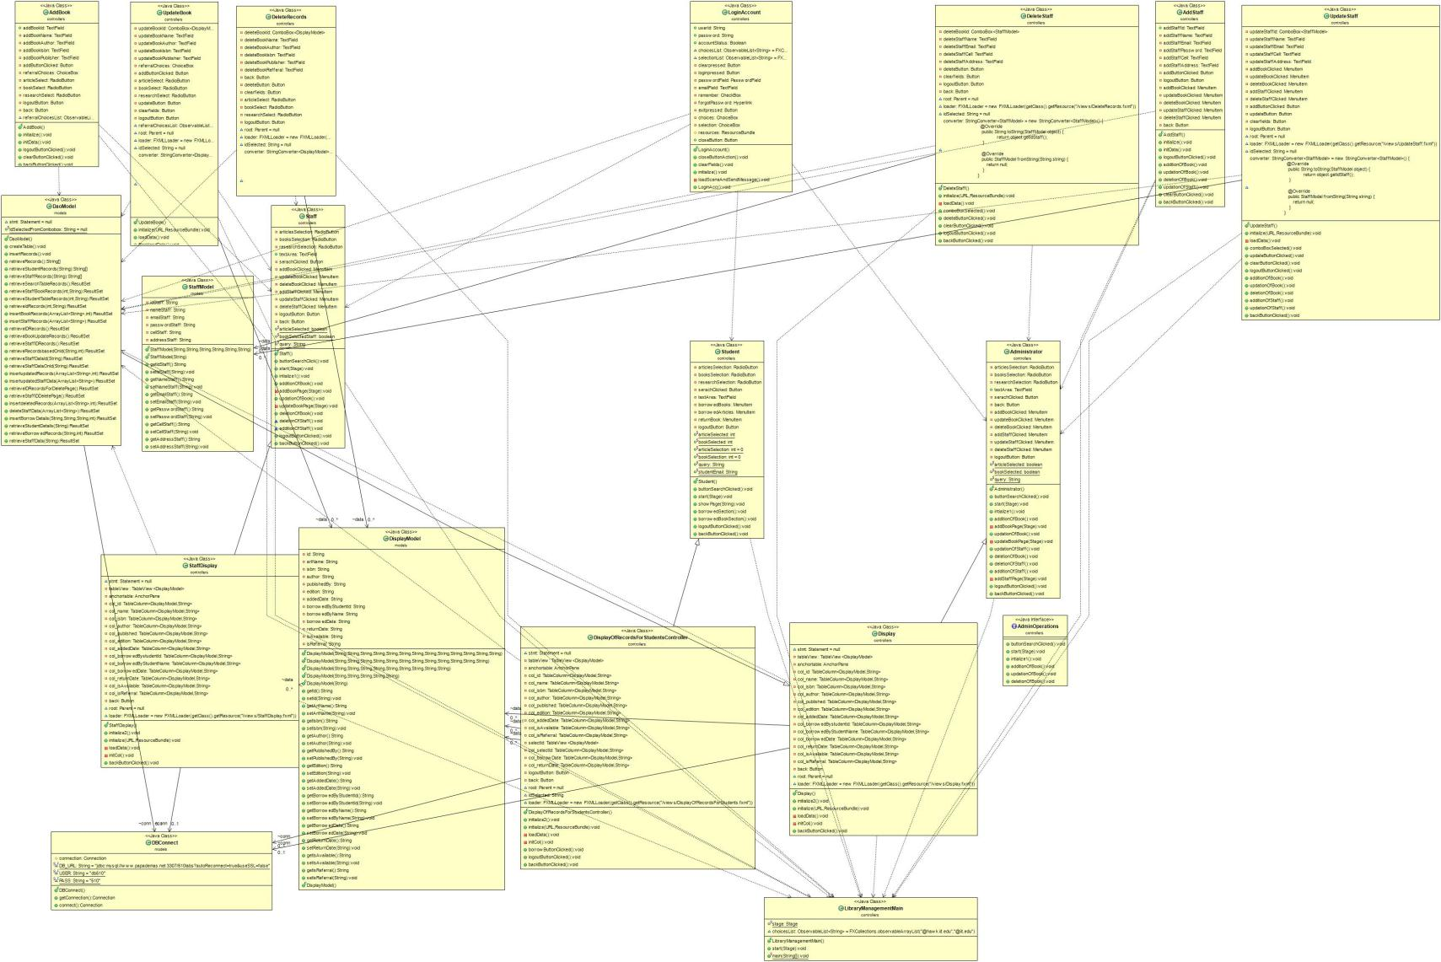



# DDL STATEMENTS

Below are the CREATE TABLE queries that are used to create table. To avoid SQL injection we have used Prepared Statement.

# TABLE CREATION

**Administrator Table:**

CREATE TABLE administrator(  
adminId VARCHAR(9) NOT NULL,  
username VARCHAR(25) NOT NULL,  
password VARCHAR(10) NOT NULL,  
phoneNumber VARCHAR(10) NOT NULL,  
PRIMARY KEY(adminId));

**Staff Table:**

CREATE TABLE staff (

EmployeeId VARCHAR(9) NOT NULL,

StaffName VARCHAR(45) NOT NULL,

Username VARCHAR(10) NOT NULL,

Password VARCHAR(10) NOT NULL,

PhoneNumber VARCHAR(10) NOT NULL,

Email VARCHAR(20) NOT NULL,

StaffAcessGrant BIT(1) DEFAULT b'0',

Address VARCHAR(60),

PRIMARY KEY (EmployeeId),

FOREIGN KEY (EmployeeId) REFERENCES administrator (AdminId),

FOREIGN KEY (EmployeeId) REFERENCES student (StudentId),

FOREIGN KEY (EmployeeId) REFERENCES student (StudentName),

FOREIGN KEY (EmployeeId) REFERENCES student (Username));

**Student Table:**

CREATE TABLE students(

studentId VARCHAR(9) NOT NULL ,

studentName VARCHAR(30) NOT NULL,

usernameOrEmail VARCHAR(30) NOT NULL,

password VARCHAR(10) NOT NULL,

phoneNumber VARCHAR(10) NOT NULL,

address VARCHAR(60) NOT NULL,

major VARCHAR(40),

minor VARCHAR(40),

securityAnswer1 VARCHAR(20),

securityAnswer2 VARCHAR(20),

studentAcessGrant BIT(1) DEFAULT 0,

PRIMARY KEY(studentId));

**Book Table:**

Create table bookstable (id VARCHAR(9) not NULL,

name VARCHAR(100),

isbn VARCHAR(20),

author VARCHAR(45),

publishedBy VARCHAR(100),

edition VARCHAR(20),

addedDate date,

borrowedByStudentId VARCHAR(9),

borrowedByName VARCHAR(45) ,

borrowedDate DATE ,

returnDate DATE ,

isAvailable VARCHAR(3) ,

isRefferal VARCHAR(3),

PRIMARY KEY ( id ));

**Article Table:**

Create table articlestable (id VARCHAR(9) not NULL,

name VARCHAR(100),

isbn VARCHAR(20),

author VARCHAR(45),

publishedBy VARCHAR(100),

addedDate date,

borrowedByStudentId VARCHAR(9),

borrowedByName VARCHAR(45) ,

borrowedDate DATE ,

returnDate DATE ,

isAvailable VARCHAR(3) ,

isRefferal VARCHAR(3),

PRIMARY KEY ( id ));

# LIST OF DATABASE ENTITIES

The list of table names that has been used to develop this project are,

* 510labs.administrator
* 510labs.stafftable
* 510labs.students
* 510labs.bookstable
* 510labs.articlestable

**LIST OF CREDIANTIALS FOR LIBRARY MANAGEMENT SYSTEM:**

|  |  |  |
| --- | --- | --- |
|  | Username/Email | Password |
| Administrator | [ritsree@iit.edu](mailto:ritsree@iit.edu) | admin@123 |
| Staff | Jackson@hawk.iit.edu | CHIC@123 |
| Student | [svijayakumar1@hawk.iit.edu](mailto:svijayakumar1@hawk.iit.edu) | IIT@123 |

# ENTITY RELATIONSHIP DIAGRAM

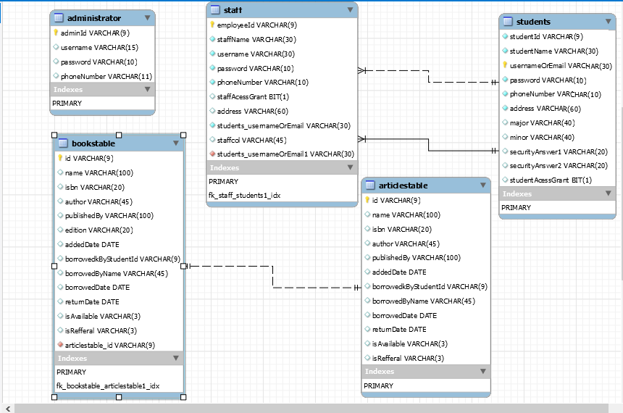

# WORKING-SCREENSHOTS

Login Page:

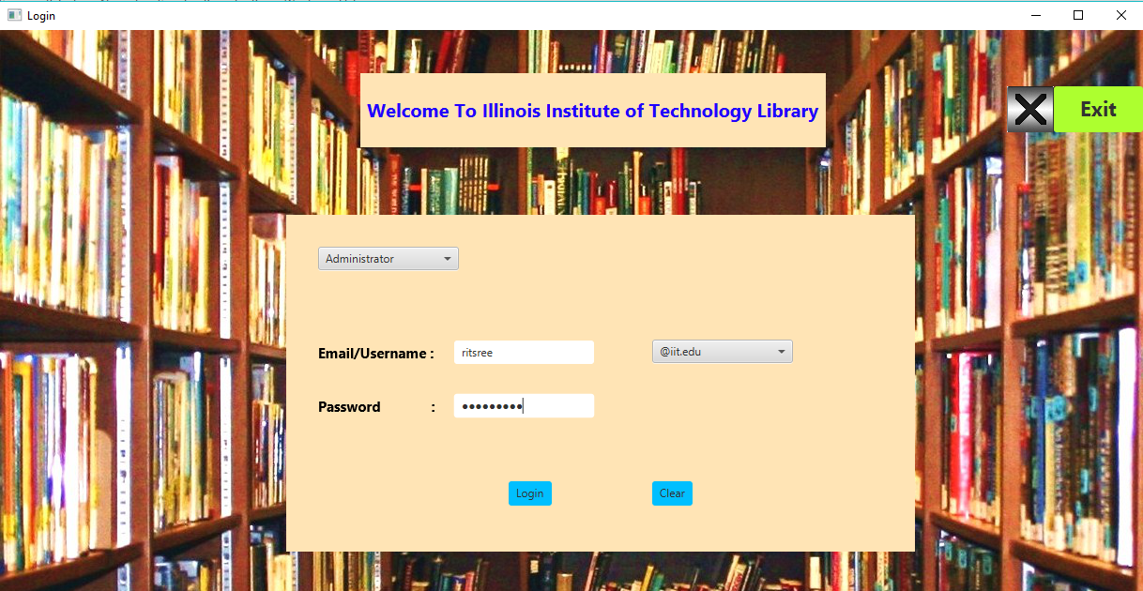

Admin Page after enter:

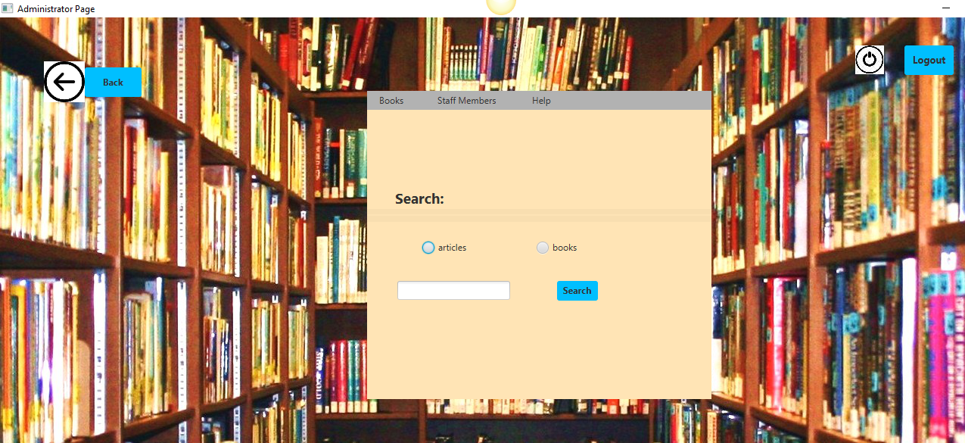

Articles retrieved from database when search is clicked:

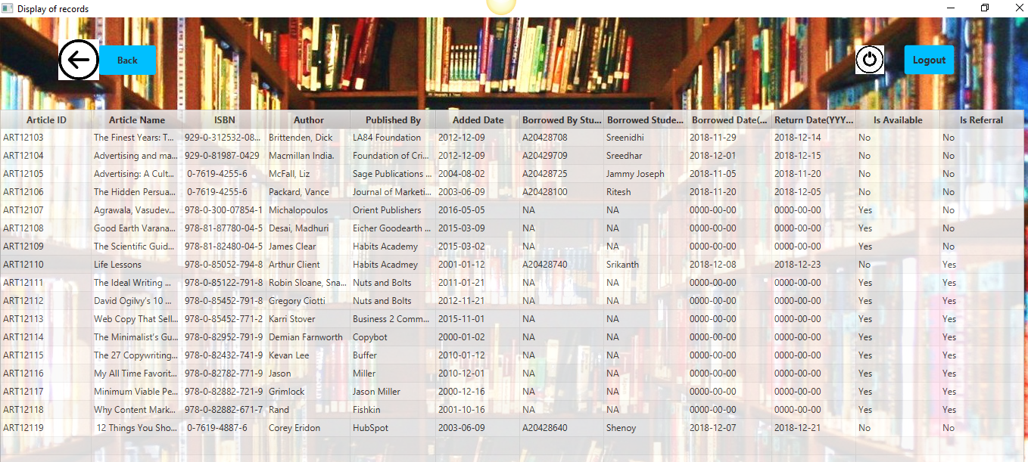

Books retrieved from database after clicking the search button:

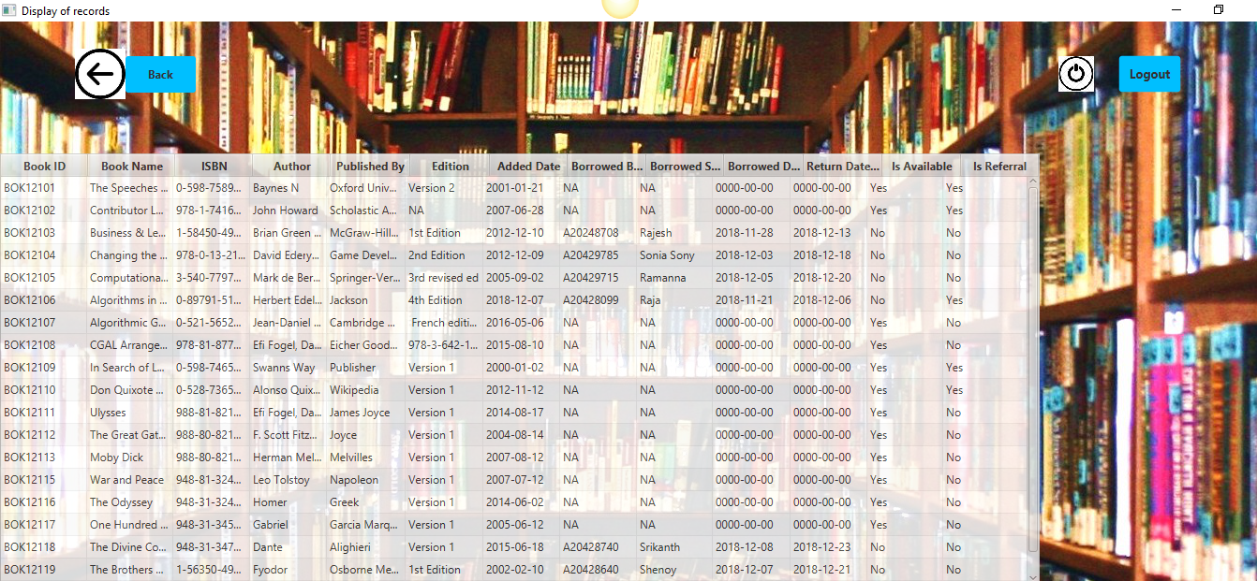

Adding a Article/book successfully in the database:

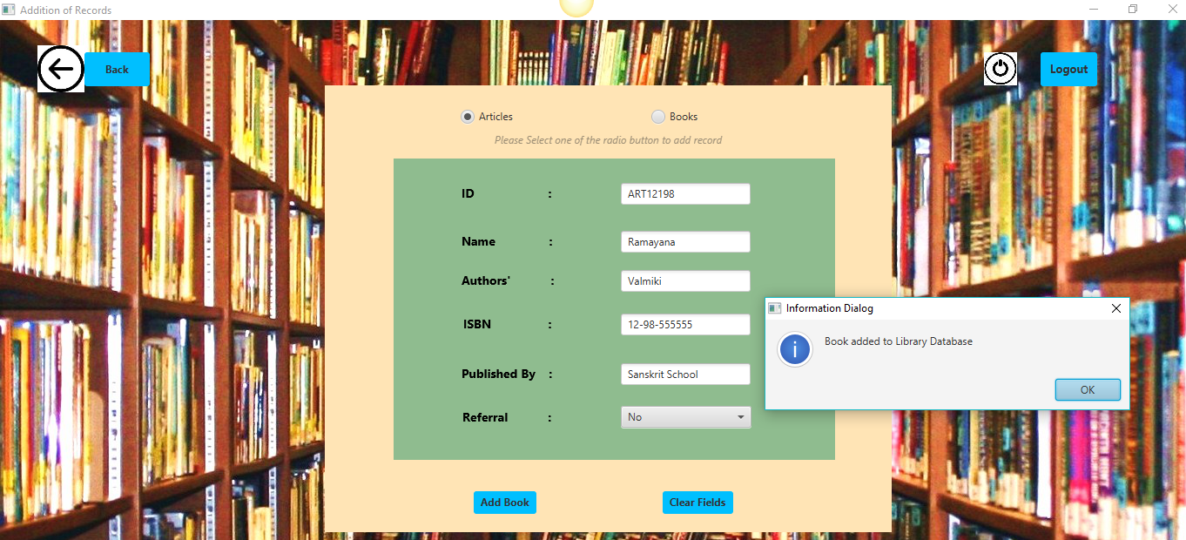

Update a Article/Book in the database

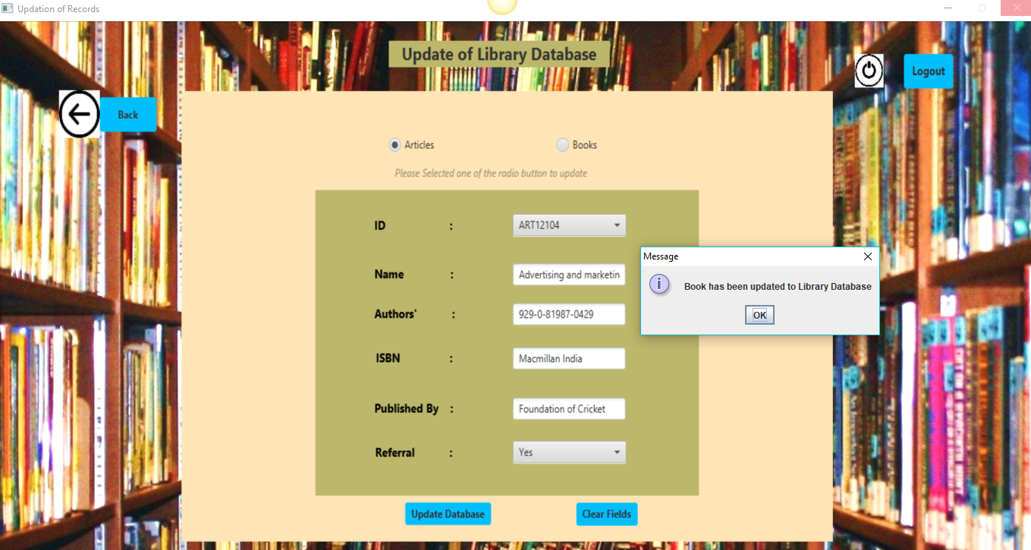

Delete a Article/Book in the database

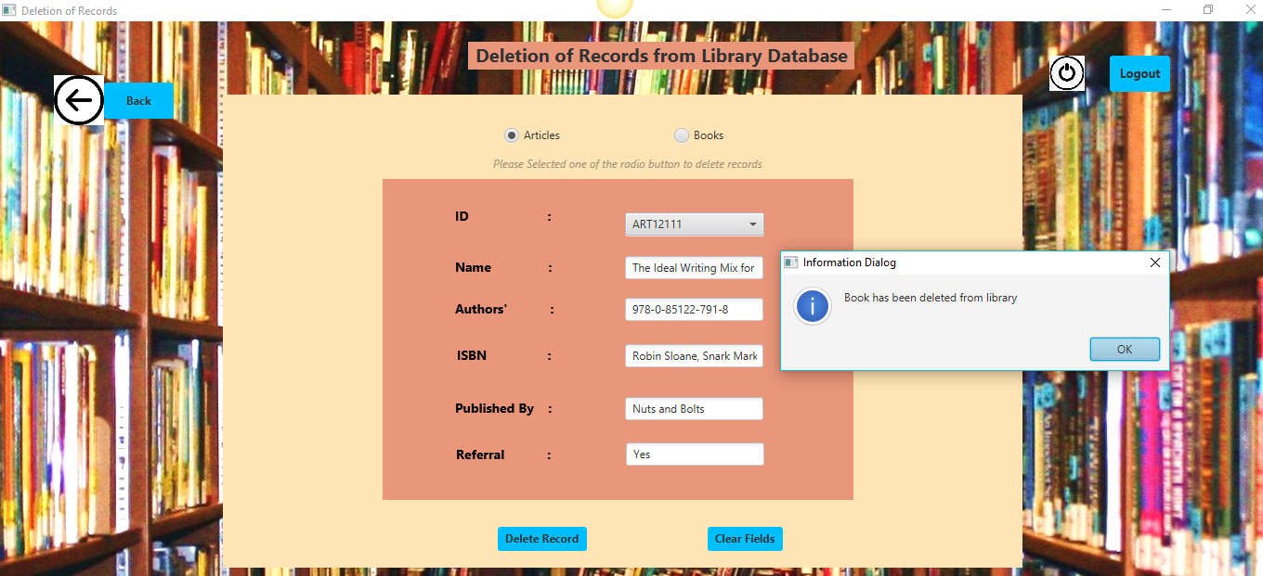

Adding Staff:

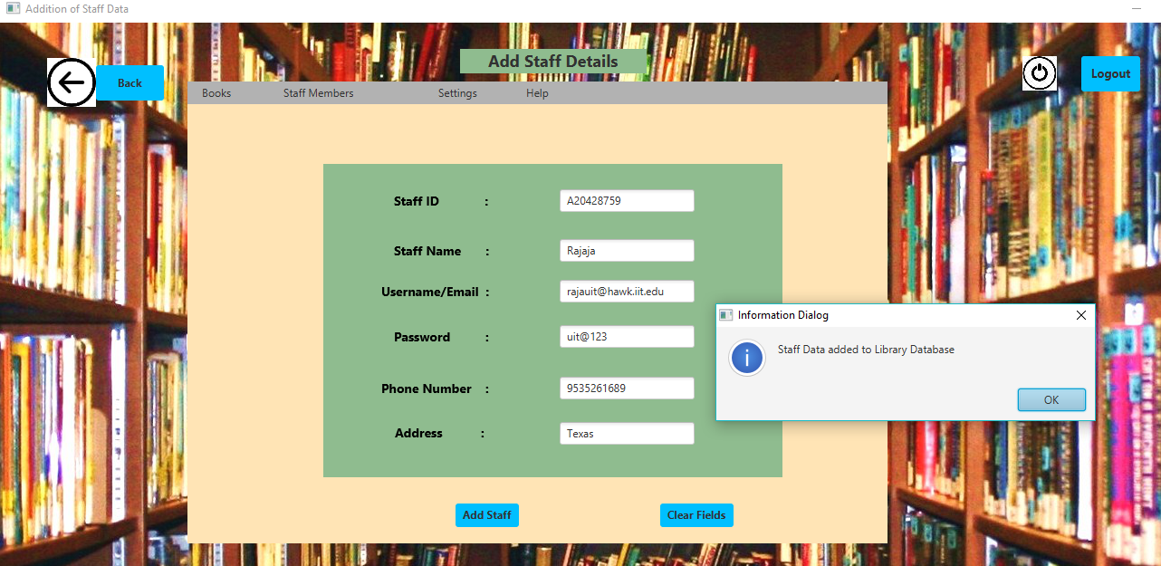

Updating Staff:

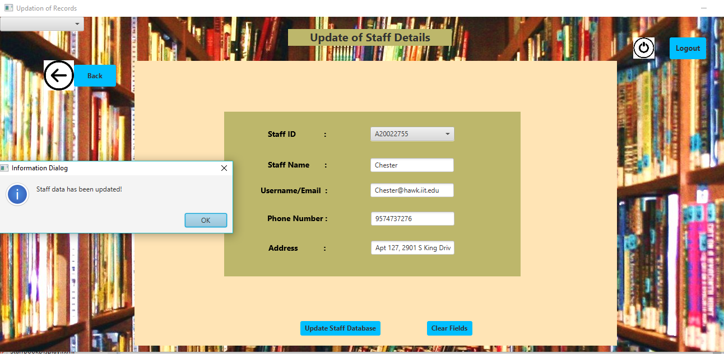

Deleting the Staff:  
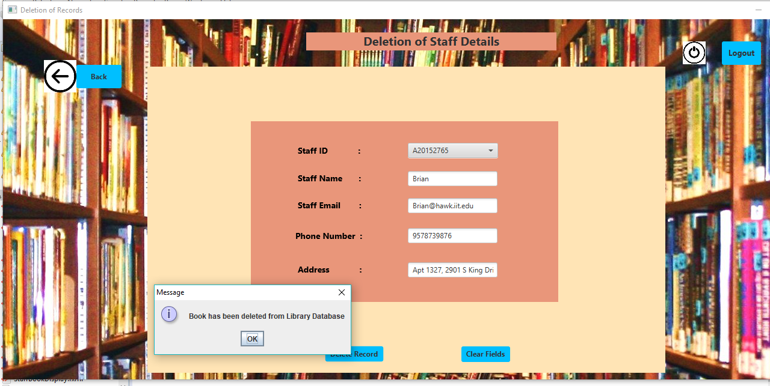

Staff Page After Login:

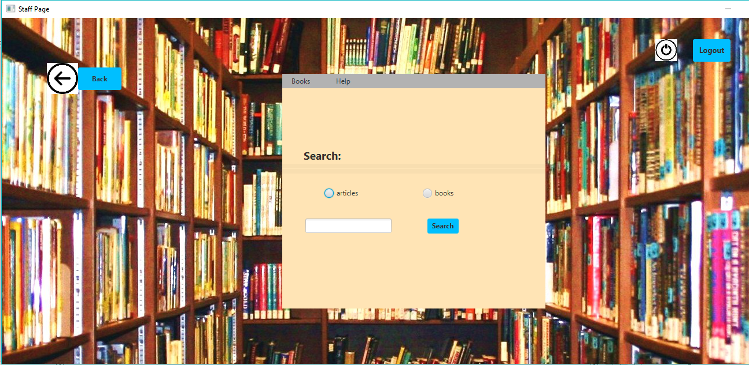

Student Page:

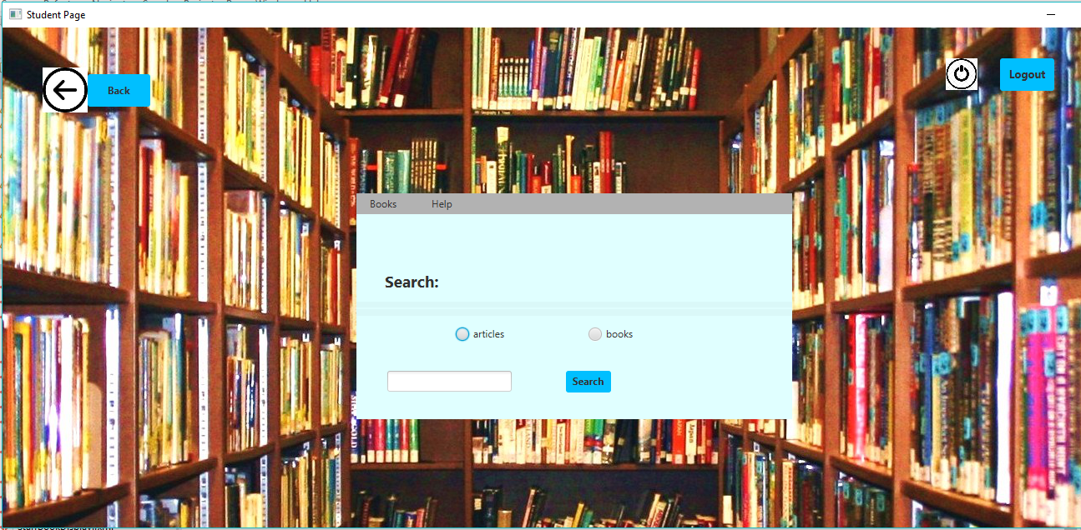

Student Borrowing the book:

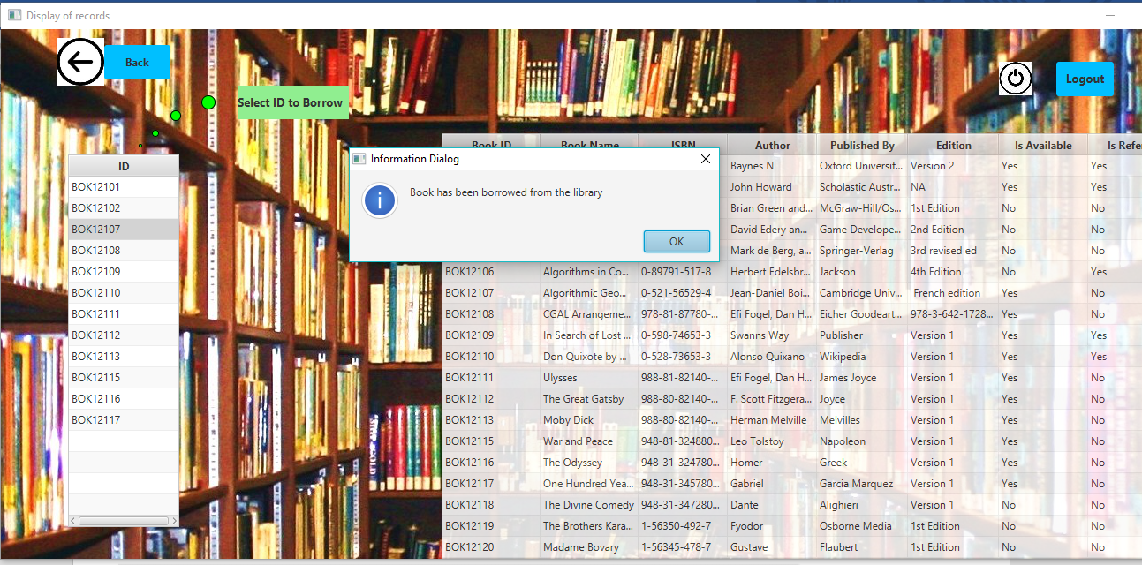

Help Page:

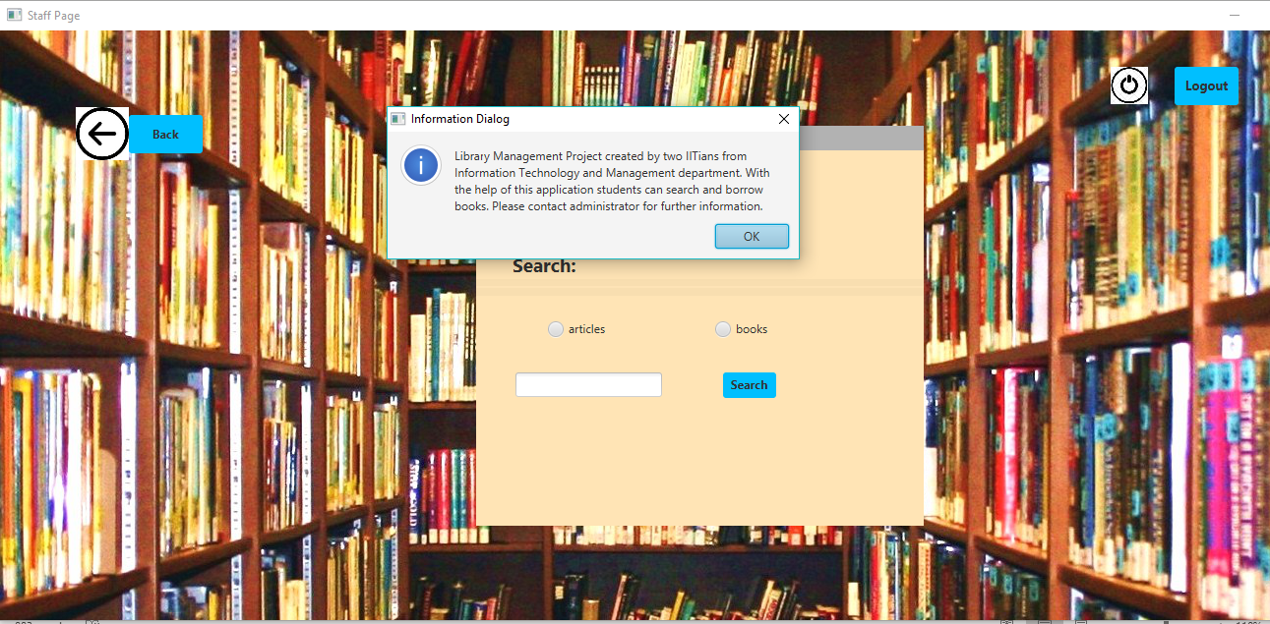

# DATABASE-SCREENSHOTS

Administrator Table View:

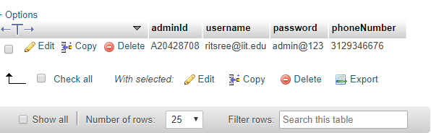

Article Table View:

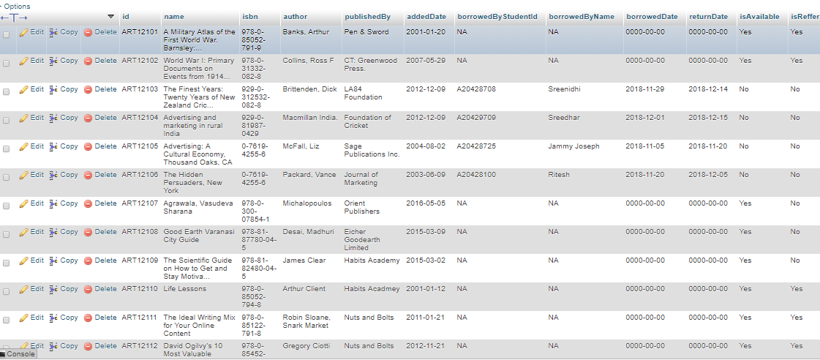

BooksTableView: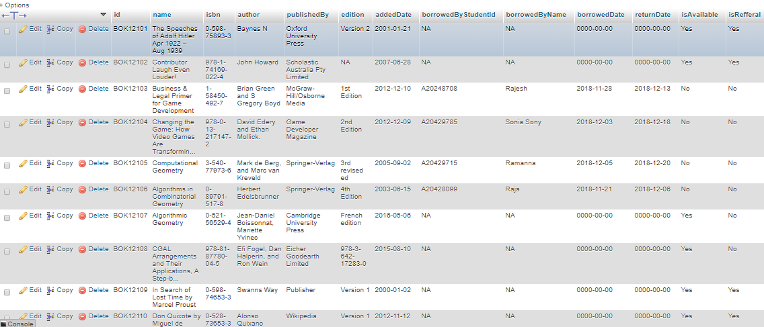

Staff Table View:

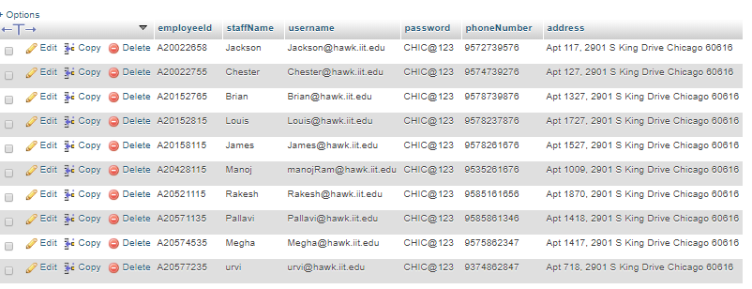

Students Table View:

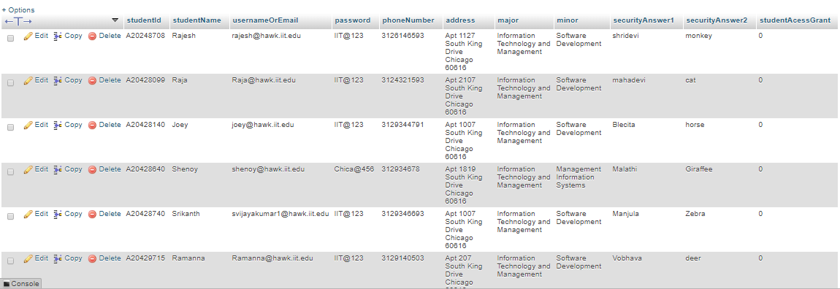

# ERROR HANDLING-SCREENSHOTS

Empty Add Page for Book:

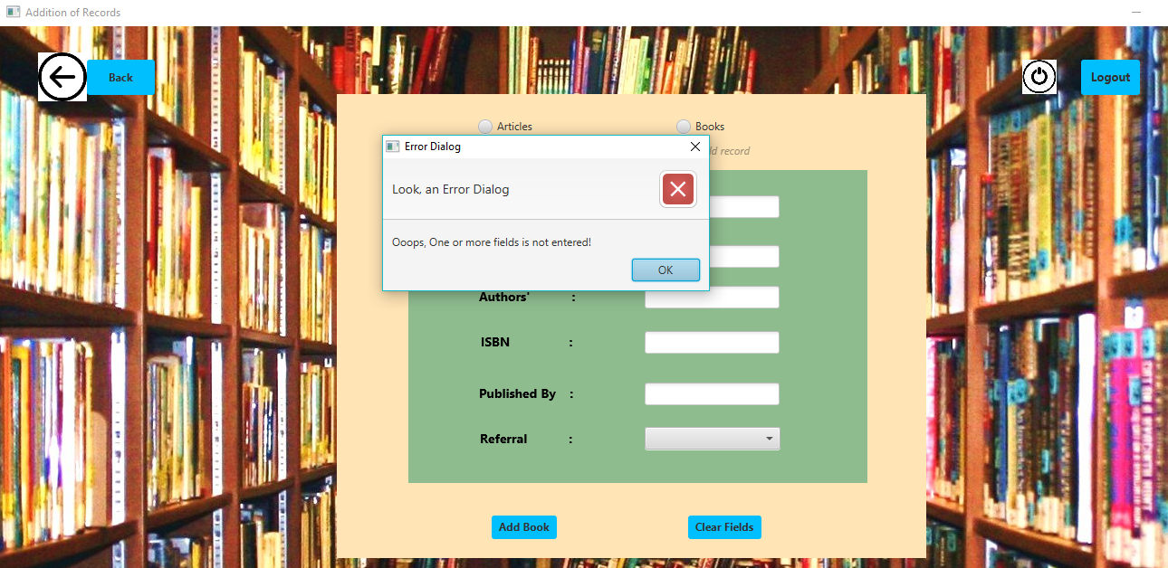

Invalid Entry of while adding book:

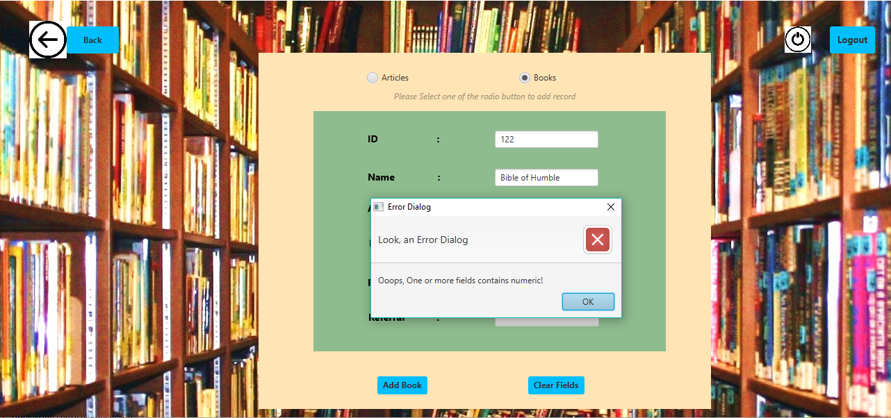

Updating Database for books:

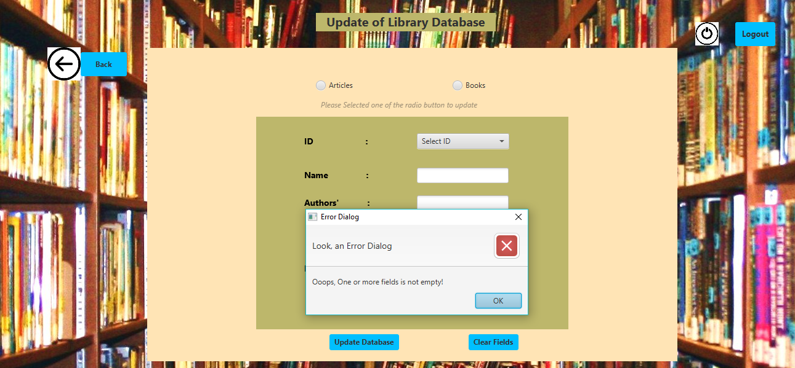

Logging without Selecting Type of use and entering no fields:

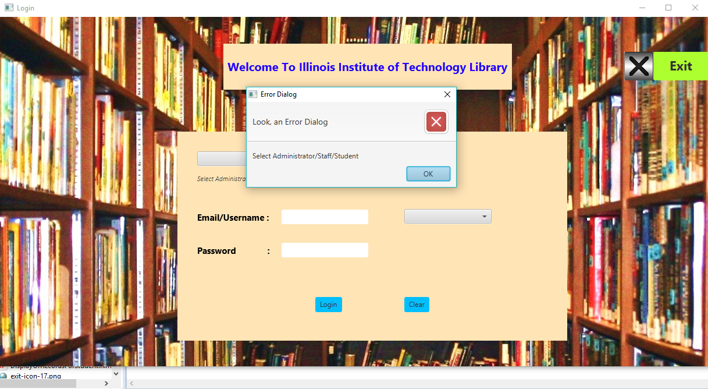

Logging without user name and Password :

